...

The
Presentation Skills Workshop

Table of Contents

Medium of Presentation 2
Most Common Mistakes 3
Non-verbal-Paralinguistic Elements 4
Analysis Chart 5
Eight Traits of a Good Speaker 8
Presenting Your Partner 10
Using Memorable language 11
Providing Feedback 12
Planning and Organizing 14
Opening a Presentation 15
Organizing your Talk 16
Magnificent Seven 17
Speaking Spectrum 18
Opening 19
Exercise 1 19 a
Possible Goals 21
Rehearsing the Speech 22
Possible Topics for Your Talk 23
Preparing Notes 24
Providing Feedback (2nd talk) 25
When to Use Visual Aids 26
Rule of Six 27
Lettering Size 28
Flipchart Design Tips 29
More on Visual Aids 30
Room Arrangemen1:S 31
Some Useful Numbers 32
Handling Questions 33
Managing Challenging Questions 34
Quotes for Presenters 35
Assorted Quotes 36
Persuasive Words 36 a
Words You Want 37
Bibliography 38
Some Useful Web Sites 39

The Medium of Presentation

Let's start by asking ourselves - why have we chosen the medium of live presentation - the medium of ourselves, of an in-person talk - as a medium of delivering information? Why have we been chosen to communicate information in this way rather than by preparing a report or sending out a circular?

Since we have chosen the medium of live presentation, we want to make the most of it by maximizing the use of its various elements. These elements are both non-verbal and verbal.

Let's take a few moments to discuss - what makes good presentation? Write down what you consider to be some features of a good presentation. Then compare your notes with those of your partner.



"The medium is the message. " -Marshall MacLuhan

2
MOST COMMON MISTAKES

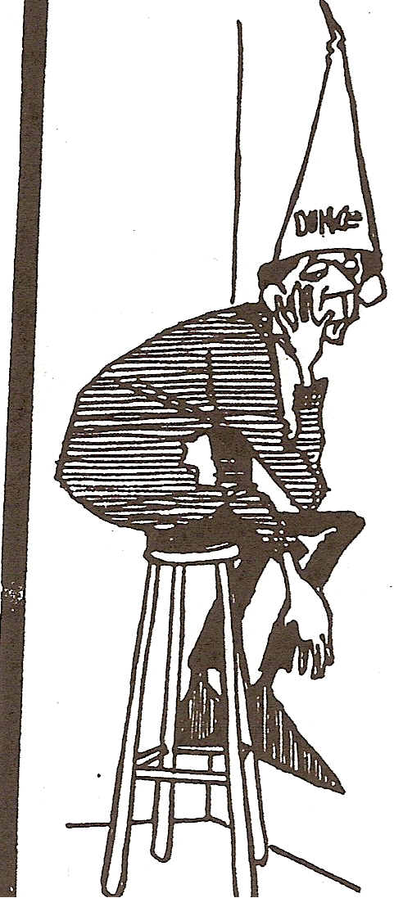

1. | Poor 1st impression.
2. | No objectives
3. | Dull, dry, and boring
4. | Frozen in one spot
5. | Weak eye contact
6. | Poor facial expression
7. | No humor
8. | Poor preparation
9. | No audience involvement
10. | No enthusiasm/conviction
11. | Poor visual aids
12. | Weak close

3

Since we have chosen the medium of live delivery, we want to make the most of it by maximizing the use of its various elements, which are non-verbal, paralinguistic and verbal. Let's start by discussing some non-verbal elements of the presentation:

Non-Verbal Elements

eye contact

posture

facial expression

gesture

Paralinguistic Elements

pause

intonation

pacing

fillers

What is the importance of the above features in communicating information? How might each one enhance or detract from the message being communicated?



4

Let's watch some videotapes of speakers and analyse the non-verbal aspects of their presentations. As you watch each speaker, rate each one by giving a (+ ) or a (-) for each of the aspects listed:

Speaker | eye | posture. | gesture | facial ex- | voice tone | pauses | intonation | fillers
 | contact |  |  | pression
1st speaker
2nd speaker
3rd speaker
4th speaker
5th speaker

Compare your ratings with those of your partner. Are they the same or different?



“The mind is a wonderful thing. .It starts working the minute you’re born, and never stops until you get up to speak in public.” -.Roscoe Drummond

5
Eye Contact

Second to the voice, eye contact is one of the most powerful tools you have as a presenter and communicator. Establishing eye contact with members of your audience assures them of your credibility, honesty and interest in them. When doing a presentation before a video camera, be sure to look directly into the lens. This will give your viewers the sense that you are making eye contact with them. Eye contact reinforces your intention to have a conversation with your audience, thus dispelling the "we vs. They" message. It allows you as a speaker to establish a rapport and win the trust of the listener /viewer. A sense of trust will help to lower the anxiety level of audience members, thus making them more open to receiving your message.

. Gestures

Gestures can help describe, clarify and highlight your ideas. Hands are a presenter's tools. Keep them at about waist level, ready for gesturing. Keep a firm wrist, an open hand and curved fingers. Do not hold hands tightly closed or stiffly at the sides, behind the back or in pockets. Your hands should convey a sense of assertiveness and balance. Facial expression should vary according to the information being delivered. Just as speakers should not deliver information in a monotone voice, so they should not limit themselves to as single facial expression throughout their talk. Variety is the .key to holding audience members' interest and thus successfully conveying your message to them.

Pauses

In a spoken presentation, pauses serve the same function as paragraphs in a written text. A speaker's pauses break up the information s/he is delivering into' manageable chunks that
the reader can take in bit by bit. If information is delivered too quickly without being separated into logical thought-groups, then much of it will be lost on the listener
(remember to limit the use of fillers - too many "ahs" or "ums" - during your pauses).

6
Fillers

Most speakers will use an occasional filler ("ah" or "urn") now and then and this is
. acceptable. If a speaker uses too many of these fillers, however, they can distract an audience from taking in the speaker’s message. The listeners may begin to listen for the next "ah" or "urn" and lose the train of the speaker's line of reasoning. Many speakers rely on fillers because they find the silence of the pauses a bit unnerving. The fact is, audiences appreciate. a silent pause no and then so they have a chance to absorb and digest the new information the speaker is delivering. Furthermore, "filler-less" dramatic pauses have great power to highlight selected parts of the speakers message.

Pacing

Connected to "filler-less" pauses is proper pacing. Speakers should deliver information at an appropriate speed, so that the audience is able to take it all in and not miss any of the important points the speaker wants to get across. Nervousness sometimes causes speakers to accelerate their speed because they want to get their public speaking experience over with as soon as possible. Experienced public speakers, however, learn to look at the faces of their audience members for cues as to how well their information is registering, and adjust their speed of delivery accordingly.

Intonation

Using appropriate intonation or contours of the voice is an important factor in aiding audience members' comprehension of the speaker's message and in maintaining their interest in it. The most fascinating information, if delivered in a monotonous voice or with faulty intonation patterns, can be lost on an audience. Proper intonation might be compared to the proper playing of a musical composition - the most beautiful music ever
written will not be appreciated if it is played by a musician without a sense of the musical
phrasing. .

7
.. The Eight Traits of a Good Speaker

The following are the eight traits of a good speaker. Many of these qualities are communicated non-verbally or paralinguistically

1. presence

2. empathy

3. credibility

4. sincerity

5. enthusiasm

6. dynamism

7. authority

8. ability to listen and respond to questions

Which of the above qualities do the videotaped speakers convey in their delivery? Which non-verbal elements contribute to their conveying these qualities?



"Where vision is translated into words, where words are translated into action - there is a successful speech.” Rev. Peter J. Gomes

8

Presenting your partner
10

Guide Questions

What image of my partner do I want to convey to my audience?

How can my audience benefit from knowing something about my partner?

Is there something about my partner that can
Inspire my audience?
elicit empathy from my audience? provide a model for my audience?

Here are some images of partners chosen .by participants in past Presentation Skills Workshops: .

A Man/Woman with a Wide and Varied Background

A Man/Woman on the Way Up

A Man/Woman who Strives to Balance the Professional and Personal Sides of Life

A Man/Woman who Appreciates the Finer Things in Life

A Man/Woman Dedicated to His/Her Career

A Man/Woman Who has a Lot in Common with Me

You may select one of the "images" above or any other that seems appropriate. The point is - not to tell everything there is to tell about your partner - but to narrow down your information to focus in on a particular aspect of him or her.

Using Memorable Language

Speak in Threes

If we analyze some of the great speeches in history, we find a common feature is speaking in threes. The speaker puts together three parallel structures to create a memorable effect.' Here are some examples below:

Of the people By the people
For the people

I came.
I saw.
I conquered.

Friends,
Romans, Countrymen, Lend me your ears.

Use contrast

Ask not what your country can do for you. Ask what you can do for your country.

That's one small step for man. One giant leap for mankind.

Use Quotes

“We all need to keep working and interacting with one another in the global arena today. How we say something today may be remembered for a long time, far longer even than what we say.”-Alka Prakash

11

Providing Feedback

Now watch the videotaped introductions and put your' +' and '-' ratings of each in the chart below:

 | eye contact | posture | gestures | pauses/pacing | intonation | projection | fillers
1st speaker

2nd speaker

3rd speaker

4th speaker

5th speaker

Also, keep the following questions in mind:

1 ) Does the presenter smile and greet the audience?

2) Does the presenter use memorable language?

3) Does a clear image emerge of the person being introduced?

4) Are audience members told why they might like to know the person being
introduced?

5) Does the introduction have a sense of closure, or does it just end abruptly?

Write any other comments:

12

Session II

Review: What would you say if. . .? .

Imagine that a colleague of yours tells you s/he is going to make a presentation. Your colleague asks you for some tips on how to give an effective presentation. What do you tell him or her?

Jot down a few pieces of advice, then put them together with those of your partner.

____________________________________________________________________________________________________________________________________________________________________________________________________________

Watch a bit of a video on Presentation Skills and see how your tips match with those offered in the programme. .



“Great necessities bring out great virtue." -Abigail Adams

13

r

Planning and Organizing a Presentation

When you plan a presentation, first determine your objectives: just what is it that you want your audience to do, to believe or to feel as a result of your presentation?

Let your audience know the main purpose of your presentation right from the start. Also let the audience know how the situation or change you are describing or proposing will benefit them. The "WIIFM" ("What's in it for me") factor is always a strong one. State the main purpose of your presentation and any benefits to the audience members
early on to capture their interest and make them feel your talk is relevant to their concerns.
. .

Anticipate and address any issues the audience might raise about the situation you are describing to them. If their concerns are unaddressed or glossed over, audience members can feel their time has been wasted and. the presenter's purpose in giving the presentation will have been defeated.

Wherever possible, use vivid, concrete examples to illustrate your points. If explanations are too abstract, e.g., too reliant on statistics and figures, audience members may have trouble keeping focused.

Give your presentation a strong closing that restates your major point(s) and moves your audience to action or to a new perception of a situation.



14
Opening a Presentation

Decide which type of opening you would like your talk to have:

…Glide-in - a pleasant greeting and introduction of your topic

…Grabber - a joke, a startling statement, a rhetorical question, a
striking quote

…Billboard - an overview or list of all the major items your talk will
cover

No matter which style opening you choose, be sure to tell your audience right from the start why you are making this presentation.

In the body of your talk, include vivid examples to illustrate, inform or convince your audience of your main point.

Decide on a closing that will reinforce the main idea you want your audience to walk away with.

Your last sentence should have a lasting impact.



15

Organizing Your Talk

Introduction: Include a joke, anecdote, quote that relates to your topic, e.g.,
"'Knowledge is power.' These words are as relevant today as they were when Sir Francis Bacon first wrote them back in the year 1597."

Topic sentence: State the subject, e.g., "Today I'd like to talk to you about increasing your knowledge, and thus your power. by taking advantage of the many training . workshops offered to st.1ff members. "

Purpose sentence: Tell the audience why you are speaking to them about this topic, e.g., "I feel all of us staff members should take advantage of the training opportunities offered here in our workplace. By continually developing our skills, we can develop our career potential and thus or possibilities for contributing to the Organization."
. .
Background: Give the audience some relevant background information, e.g., "For many years, the Organization has offered staff courses in computer training, and language training, and recently, it is offering even more courses in communications skills training."

Examples:

Example 1:
Computer training (what it is, how it can benefit
audience)

Example 2:
Language and Communications skills training (what it is, how it can
benefit audience)

Conclusion: Conclude by showing the audience how everything you've told them demonstrates the truth of what you stated in your purpose sentence, e.g., "Therefore, the skills we learn in these various training programmes can help us be more effective in our . present tasks and prepare us for possible future tasks so we can contribute more to the Organization. Remember. 'Knowledge is power.'"

16

The Magnificent Seven

To make it easy for your audience to follow you every step of the way, a presentation should include seven component parts:

1.grabber (an anecdote, quote or startling statement)

2. introduction

3. topic sentence

4. purpose statement

5. background

6. body with vivid examples

7. conclusion (echo your purpose by restating it)

It could also be useful to conceive of the components of a presentation visually. Let's imagine these components as a rainbow with seven 'arcs' of information.



“In science, credit goes to the man who convinces the world — not to the man to whom the idea first occurred." -Sir Francis Darwin

17

The Speaking Spectrum

Include all seven I arcs' of information
to create a talk full of color and inspiration!

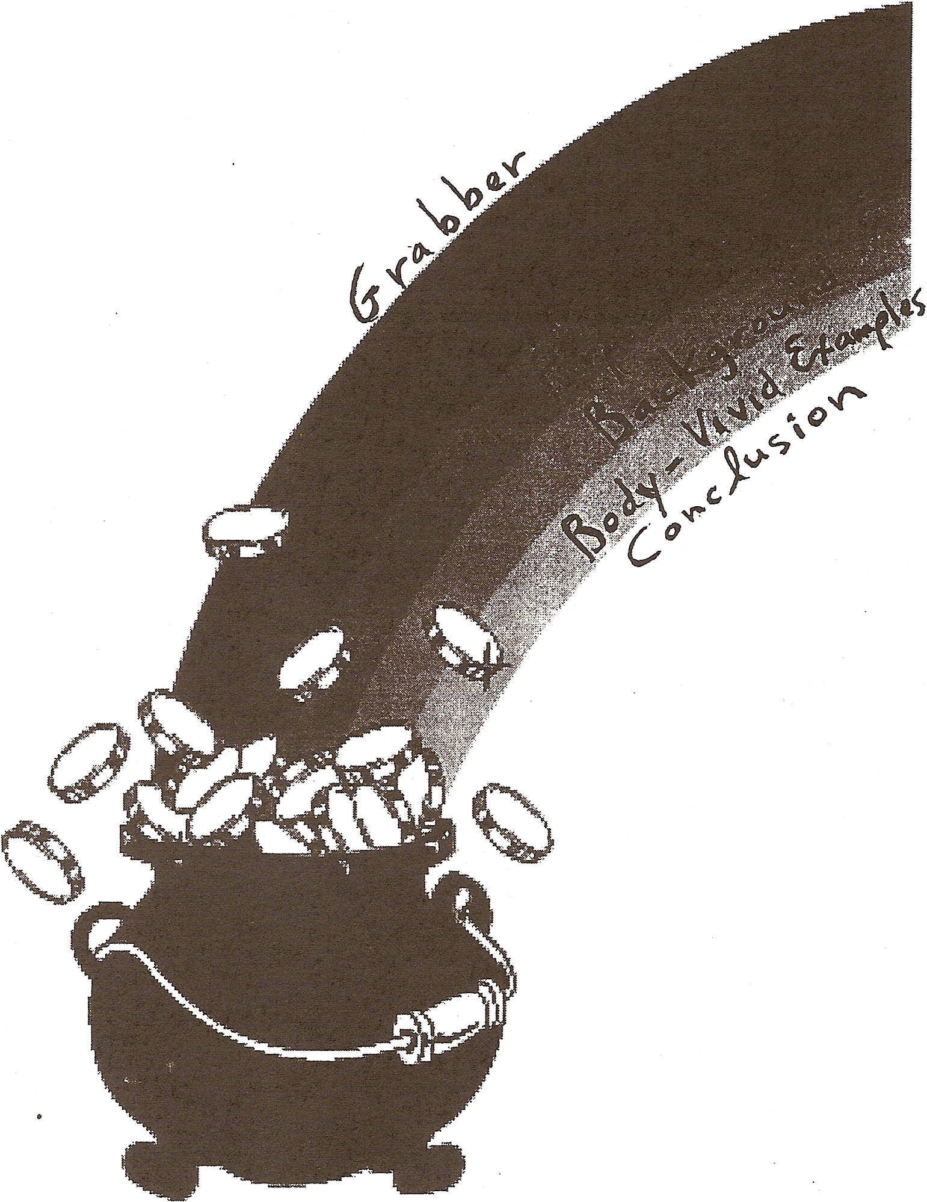

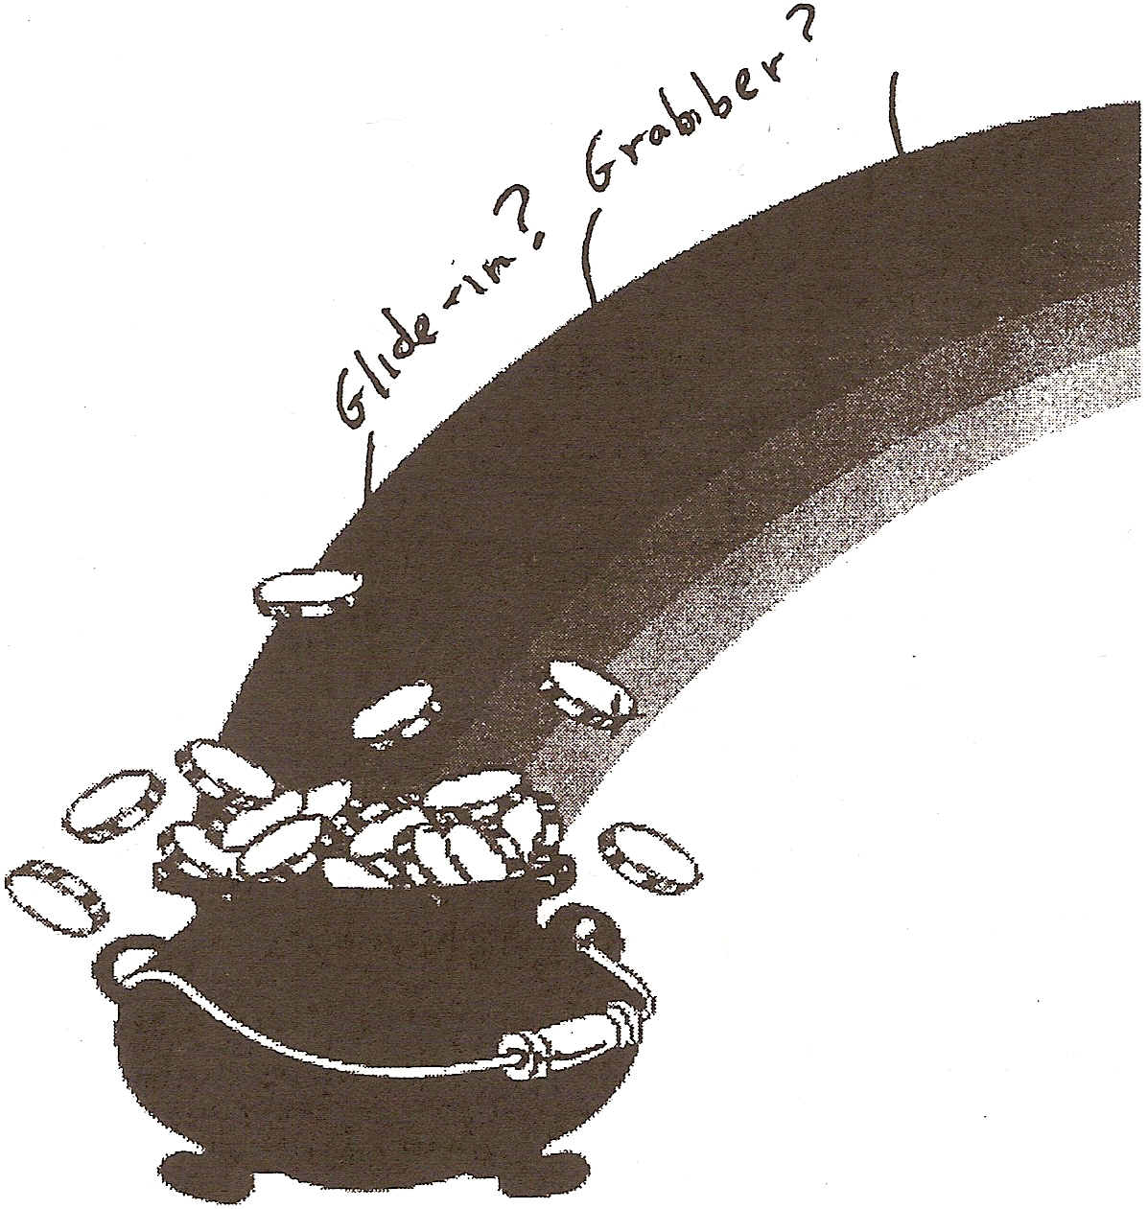

18

14,
The Opening
It's important that you "win" your audience over at the beginning of your talk when their attention level is high. Make the most of this opportunity by deciding on an effective opening.

Decide which type of opening you would like your talk to have:

A Glide-in - a pleasant greeting and introduction of your topic A Grabber - a startling statement, rhetorical question, striking
A Billboard - an overview or list of all the major items your talk will cover
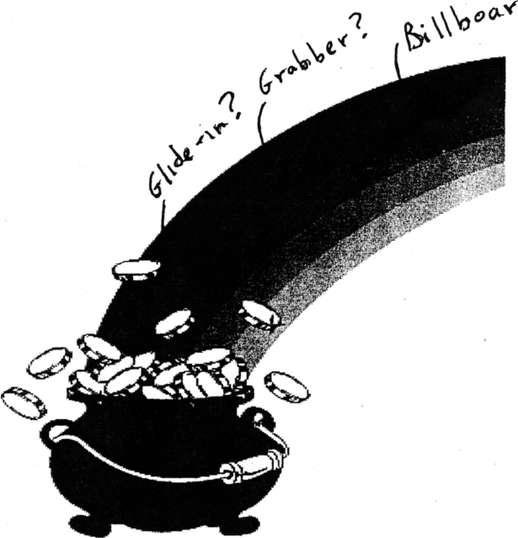

19

Presentation Skills Exercises

Exercise 1

Set up and Speak Out:

Prepare the beginning of a talk on one particular aspect of your work or area of expertise. In this part of the talk, include just your greeting, topic and purpose. Develop your topic by providing an example that helps capture the point you want to make. Then give the audience a preview of what you will talk about in the second part of your talk at the next meeting of the group

Before delivering your talk to the group, set a goal for yourself. Decide on an aspect of your delivery {paralinguistic, non-verbal or verbal} that you'd like to pay particular attention to. Perhaps you'd like to focus on making good eye contact with your audience, or on reducing your use of fillers, achieving appropriate pacing or using more gestures. Consult the list of goals on the next page and choose one.

Practice Delivery

First, practice delivering your revised presentation in a small group. Listen carefully to the feedback you receive from your group members and make appropriate changes in your presentation notes.

Videotaped Delivery

After reviewing your notes, you will be videotaped making your presentation to the entire group. Remember to keep in mind the non-verbal aspects of your delivery.

19a
Exercise 2

Tighten up and fill out:

Keeping in mind the feedback you received, tighten up your talk by keeping within the
boundaries of the seven arcs of information. Then develop part 2 of your talk with more examples, a quote and a memorable conclusion.
.
Practice:

Practice giving this revised talk in a small group. Then prepare to make your presentation for the video camera.

Before making your presentation for the video camera, set a goal for yourself. Which of the non-verbal features of your presentation would you like to pay particular attention to? If you chose a non-verbal or paralinguistic goal last time, you might like to choose a verbal goal this time. Perhaps you'd like to experiment with incorporating a relevant quote or two, an interesting anecdote, use of alliteration, contrast or other type of memorable language into your talk.



20
Possible Goals

Non-verbal

Make more eye contact with the audience

Use a greater range of facial expressions (smiling when greeting the audience, and ending the presentation, generally matching facial expression to speech content)

Make posture centered with hands at waist level

Paralinguistic

Use more pauses

Use more intonation

Slow the pace

Reduce the number of fillers

Increase projection

Verbal

Experiment with a different type of opening (a 'grabber' instead of a 'glide-in' or 'billboard')

Be sure to have a 'purpose sentence'

Have a neater, more memorable closing

Use a relevant quote

Use alliteration

21

REHEARSING THE SPEECH

by Steve Allen

Common sense can also dictate the forms your rehearsal might take. The following are some of the possibilities:

- Read the speech over several times, silently.

- Read the speech several times aloud.

- Practice your delivery, including the entire address, standing in front of a mirror. This gives you the opportunity to observe not only your general attitude but also your gestures, posture, and facial expression.

- Read the speech into a tape recorder and listen to the results. Then listen to them again. At this stage you will make an astounding discovery. Things begin to become apparent to you at a second listening (or, for that matter, a tenth) that had escaped your attention earlier.

- If you have access to videotaping equipment, make a record of your performance in that way.

- If you have cooperative family members, deliver the speech to them and ask for their honest comments. Don't make the mistake of welcoming only compliments and tuning out messages that are analytical or critical. If your spouse says something like "I think it's quite good but you were talking too fast," don't argue the point, whether or not your ego will permit you to agree at that moment. Just absorb the message and let it bounce around in your internal computer.

-from How to Make a Speech (McGraw-Hill) 1986, material reproduced with permission of Steve Allen. .

22
Possible Topics for your Talk

Prepare a 2-minute talk that deals with a particular aspect of your work. For example:

a particular project that you're presently working on or have worked on in the past

a recent change in your job responsibilities

a recent change in the organization of your department

a particular aspect of your department that you'd like other staff members to understand better

any other work-related topic

Be sure to memorize the beginning and ending sentences of your talk.

In organizing your presentation, pay special attention to:

the opening: decide on a glide-in! a grabber! a billboard

the main point: let your audience know it right away

the body: include vivid examples that convince your audience

the conclusion: restate your main point in a "catchy" way

Practice giving your talk to your partner and time it.



23
Providing Feedback

Let’s consider the questions below as we prepare our feedback for the speaker.
As you watch the videotaped presentation, take notes to answer the questions below to provide some feedback:

1) Did the presenter meet his/her stated goal?

2) Did the presenter smile and greet the audience?

3) Was the material well organized (presented in an order that was easy to follow)?

4) Did the speaker use any examples of memorable language (quote, anecdote, example, alliteration, ‘group of three’, contrast)

5) Did the presenter refer to the audience (say “you”, for example, ‘As you know…” “Some of you may be familiar with…”)

6) Did the speaker sometimes turn statements into questions for verbal variety? (e.g., instead of introducing a new aspect of the topic with another statement, did the presenter sometimes phrase it as a question, “So—Why is it that we need this new system?”)

7) Did the presenter let the audience know the benefits of what s/he was explaining/recommending?

Other comments:

24
Preparing Notes

When preparing your notes, it's best not to write out every single word you intend to say. If you read your notes, or try to memorize every word of your written text, your presentation will have an artificial sound. You may find it helpful, however, to write out and memorize the opening lines of your talk (just to help you get started). But for the rest of your talk, simply jot down some of the main points you want to make. Write these points in large letters and be sure to number your note cards and pages so you don't get "lost. "
Write out your first two or three sentences in full:

“Knowledge is power.” These words are as relevant today as they were when Sir Francis Bacon first wrote them back in 1597. Today I’d like to talk yo you about how to increase your knowledge and thus your power to contribute to the Organization by taking advantage of the many courses we offer in the Learning Service. Some examples of courses we offer are

Then just write aspects of your topic in large, bold font (size 18 or 20) –so that you just have to glance to remember the next thing you want to say.

Let me first tell you about our courses in

1) Computer skills

Now let me describe our courses in

2) Presentation Skills

Finally, I will talk a bit about courses many of us feel we need in

3) Writing skills

24

Providing Feedback

When watching the videotapes of the course participants, use the chart to rate the nonverbal, verbal, and paralinguistic aspects of the delivery. Use a check ( ) or a (-) to rate the speakers on each of the categories:

Name | Eye contact | Posture | Gesture | Facial expression | Pauses | Pacing | Intonation | Fillers | Use of language

The Speaking Spectrum

Did the speaker include all seven 'arcs' of the 'speaking spectrum'? What comments would you like to make about each arc of information?
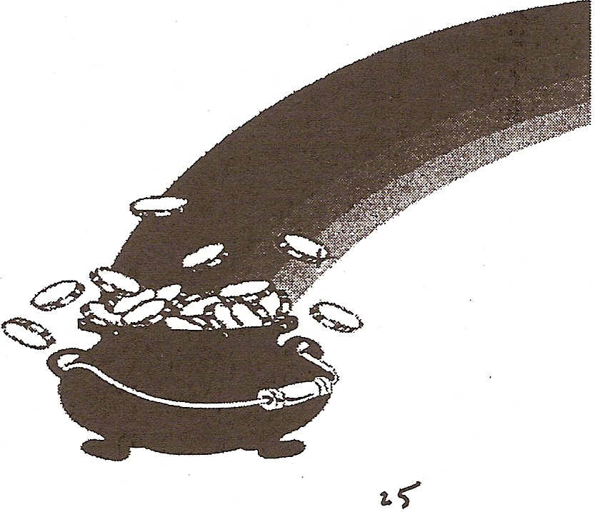

25
WHEN TO USE VISUAL AIDS

Use a visual aid to:

. 1. Clarify a point.
2. Emphasize a point. 3. Add variety.
- Change focus.

Don’t use a visual when it:

1. Distracts or detracts from the focus of your presentation.

2. Is poor quality.

3. Is irrelevant (even though it is interesting).

4. Is solely a time-filler.

5. Is outdated.

6. Doesn't suit your purpose.

7. Doesn't suit your audience.

26

The Rule of Six

Do not use more than six lines

and

Do not use more than six words to a line

This is a good rule. It is based on reading research that attempted to answer the question, "How much information can a person absorb visually at one time?" The conclusion of the study was six lines of six words each.

Of course you'll break this rule occasionally. For example, if you've got a proposal to present with seven key points you probably will want a visual that presents seven ideas. But keep the rule in mind and follow it wherever you can. Use it to decide when you need two visuals instead of one.

27

Lettering Size

1. How large should the words be?

Unfortunately, there is no simple answer, but there are a few guidelines:

- For flipcharts, white/blackboards and posters
Letters should be 1 inch tall for each 1 5 feet between the visual and the back row.

- For slides
This will vary according to the size of your audience. Letters should be clear and readable from the back row.

2. Should all caps be used?

DON'T USE ALL CAPS FOR LARGE BLOCKS OF TYPE. READERS READ FASTEST WHEN SENTENCES ARE PRINTED IN UPPER AND LOWER CASE - THE WAY THEY NORMALLY ARE SEEN IN PRINT. HEADLINES ARE SET IN ALL CAPS BECAUSE THEY REQUIRE THE READER TO SLOW DOWN, GIVING EMPHASIS TO A FEW WORDS. WASN'T THIS BLOCK OF ALL CAPS DIFFICULT TO READ?

Compare:

Don't use all caps for large blocks of type. Readers read fastest when sentences are printed in upper and lower case - the way they normally are seen in print. Headlines are set in all caps because they require the reader to slow down, giving emphasis to a few words. Wasn't this better?

28
Eight Flipchart Design Tips:

1. Choose bold colors. Avoid pastels . . . except for highlighting.

2. Your lettering should be one inch tall for each fifteen feet between the flipchart and the
back row.

3. Use the fat side of the pen's tip when you write. Lots of flipchart lettering I see is tall
enough, but it is not bold enough because the presenter uses the skinny part of the pen.

4. If you prepare your flipchart before your presentation, leave a page or two (whatever it takes to completely cover the message on the next page) in front of each page. Then you can turn to a blank sheet after each point-and the audience won't be able to see through to what's behind.

5. You can use correction fluid to cover a glitch.
6. Make light pencil notes to yourself at the top left comer of the flipchart. Then, as
you're speaking, you have reminders of important names and numbers.

7. You can use the overhead projector to size an object for the flipchart. If you want to magnify a small drawing or chart, make a transparency on your office copier. Then project it onto the flipchart in the correct size and draw it with markers.

8. Flipchart sheets have unity and impact when you add a border.

9. Center what you write/draw on a flip chart ( don’t leave uneven amounts of white space around what you write).

29

..

.
More on Visual Aids

Flipcharts

A. Preparation
1. Consider graphics instead of just words
2. Letter with dark colors/highlight with lighter colors
3. Make good use of white space (as important as large print)
4. Leave blank sheet between printed pages .
5. If you don't have grid paper, prepare a grid to place under pages during
preparation

B. Management .
t. Go to blank sheet/slide if there are long periods where no chart "fits" 2. Refer to key points during presentations/especially summaries
3. Speak to audience, not chart
4. For paced revelation ("covering" technique -progressive disclosure)

Slides

A. Preparation
- Make items on slides simple and clear
- Put line items in parallel form and of equal length
- Put only information that reinforces key points

B. Management
1. Practice machine/laptop ahead of time
2. Try to find low table/cart--blocks view less
3. "Balance" body/stance against preferred side of machine
4 . Make decisions about pointing to materials
- at machine
- at screen
- with pointer

5. Turn off laptop.projectors when not using for long periods

30

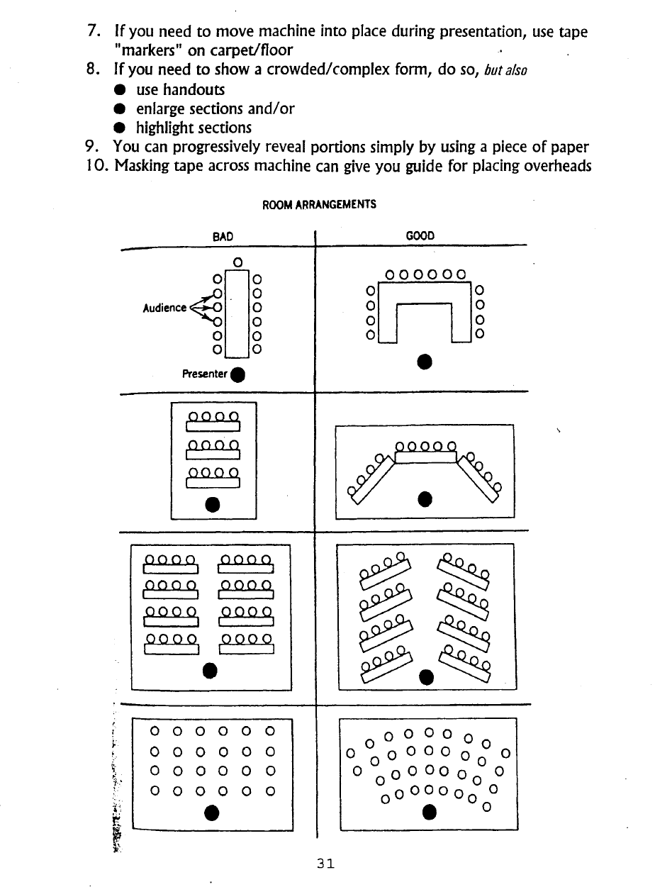

Some useful numbers
.
.

1) Presenters who stand are ___________ more effective than speakers who sit.

2) An audience remembers_____________more of the information
delivered if the presenter uses visual aids.

3) An audience retains _____________ more of what a presenter says if the visual aids are in color.

4) Visual aids should back up____________ at a time.

5) A presenter should add some "hot spice" (visual aids, jokes, stories, exercises) about every _______________minutes.

32

Session III

Handling Questions

Encourage your audience to ask questions by looking at them, smiling and waiting sufficient time. Always restate an audience member's question so that he or she feels you have really listened and understood the question. Taking the time to restate a question also gives you, the presenter, more time to think of an appropriate response.

You can spend up to 20 or 30 seconds answering any given question. If you spend more time than this, the audience can feel your presentation has become a private conversation between you and the questioner. Or, if audience members are beginning to get tired or run out of time, your long answers can make them decide to withhold further questions.

Exercise: Anticipating Questions

Take some time to anticipate questions your audience might have, especially challenging or difficult questions. Also, consider how you would handle questions that are rambling and unfocused - how you might politely "interrupt" such questioners and provide them with satisfactory responses. Think about how you might handle these questions and prepare your responses. Write your questions on note cards and hand them to fellow participants just before you deliver your talk.

33

Managing Those “Challenging” Questions

The "Yes" or "NO' or Forced Choice Question
"Are you prepared to compromise on the matter? Yes or no?"

"Is cost efficiency more important than public safety?"

RULE:

Do not respond with a simple "yes" or "no" if it is not that simple. Explain why it is not.

RESPONSES:

"The answer is both (or neither)"

"It's not that simple. Here's why..."

"You're asking me to make a choice when, in reality, there is no choice. Here's why..."

RUMOUR QUESTION

"A story that is circulating is that..."

RULE:

Do not give rumours credibility by discussing them.

RESPONSES:

"I will not respond to rumours; we'll deal with that issue if it arises."

"I've seen no evidence to support that story. Let me tell you what the facts .are."

.

ATTEMPTING TO FORCE A STATEMENT: .

"The public has been waiting for a long time to hear a statement on
this issue." .

RESPONSES:

" This issue is still under discussion. It would not be fair to the public
to speak to it prematurely. But what I can tell you at this juncture
. " .
IS...
Give whatever information you can that would be helpful to the audience.

34

Presentation Skills Bibliography

Effective Presentation Skills by Steve Mandel Crisp Publications, Menlo Park, CA. 1993 ISBN: 1-56052-2-2-X

How to Make Effective Presentations by Elizabeth Tierney Sage, Thousand Oaks, CA. 1996
ISBN: 0-8039-5956-7

How to Speak and Listen Effectively by Harvey Robbins
AMA 1992
ISBN: 0-8144-7793-3

Speaking on Issues by Ellen Echeverria Holt, Rinehart and Winston 1987 ISBN: 0-03-003433-7

Principles of Speech Communication by B. Gronbeck, et a1. HarperCo11ins 1995
ISBN: 0-6730-99176-8

Visitron: The Language of Presentations by Brian Howe Longman 1985
ISBN: 0-582-85222-6
- I
I

38
Some useful web sites for developing Presentation Skill

University of Newcastle upon Tyne
This site gives tips for presenting technical information in a clear, easy-to-understand manner
http://lorien.ncl.ac.uk/ming/Dept/Tips/present/present.htm

University of Kansas
This site explains and gives tips on the various aspects of presentations skills http://www.nwlink.com/-donclark/leader/leadpres.html

Leadership Presentation Skills
This site provides tips on organizing a talk, developing it, using effective voice tone and body language and also listening actively to audience questions
http://.www.fripp.com/articleslist.html

Free articles on Public Speaking:
This site provides articles on public speaking
http://www.rcmp::!earning.org/docslecddOOII.htm

Effective Presentation Skills
This site offers information on organizing and preparing a presentation as well as giving impromptu talks
http://staff.philau.edulbeils/ppt.html

PowerPoint and Presentation Skills Resource Page
This site links to PowerPoint tutorials and provides general tips for using the PowerPoint program effectively,
http://www.toastmasters.org

Toastmasters International
This is the official site of Toastmasters, the international, non-profit organization for people who want to improve their public speaking
http://www.toastmasters.org

39

